The magnetic storms catalog for monitoring data of radio sources fluxes at RT URAN-4, in the zone of the Odessa magnetic anomaly
The magnetic observatory «Odessa» was founded by the Novorossiysk Imperial University, in the territory of a botanical garden, at the beginning of the XX century. It was officially commissioned in 1896. In 1936 it was transferred to the village of Stepanovka (near Odessa) by the Odessa State University (fig. 1). World War 2th the station became to belong to the Institute of Geophysics.
From 1948 to 2010, analog measurements of the Earth’s magnetic field were conducted at the «Odessa» Magnetic Observatory. The magnetometers are located in a deep underground room (fig. 2-4), which makes it one of the best in Ukraine in terms of noise immunity, and the large distance from Odessa (82 km) excludes the contribution of technogenics noise to the measurements of the geomagnetic field induction. At the same time measurements of three elements of a magnetic field are registered: horizontal component (H), vertical component (Z) and inclination (D). The recorded data on magnetic storms were presented in tabular form [fig. 5].
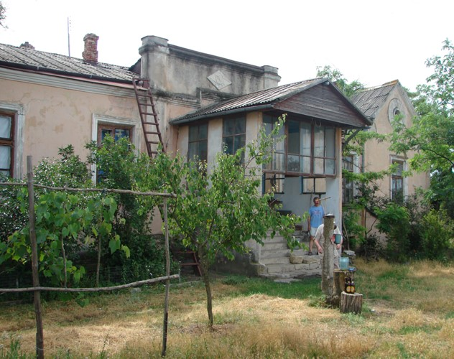

Fig. 1. Magnetic observatory "Odessa"

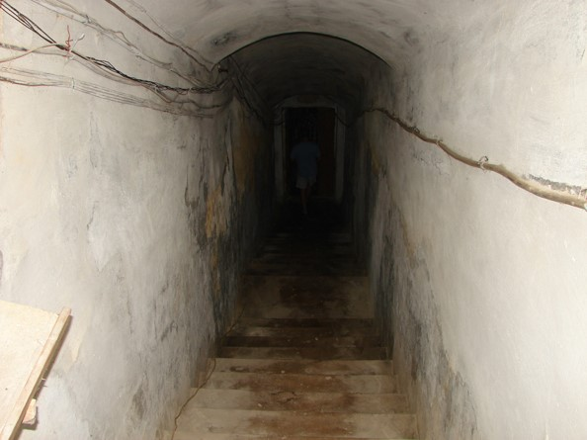

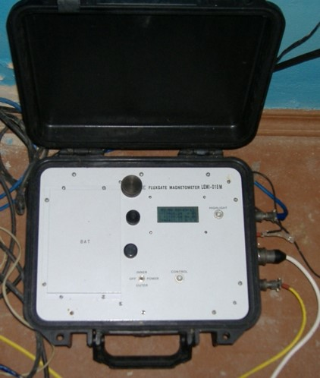
Fig. 2. Underground room of the magnetic observatory "Odessa"

Fig. 4. Underground room of the magnetic observatory "Odessa"

Fig. 3. Magnetometer of the magnetic station

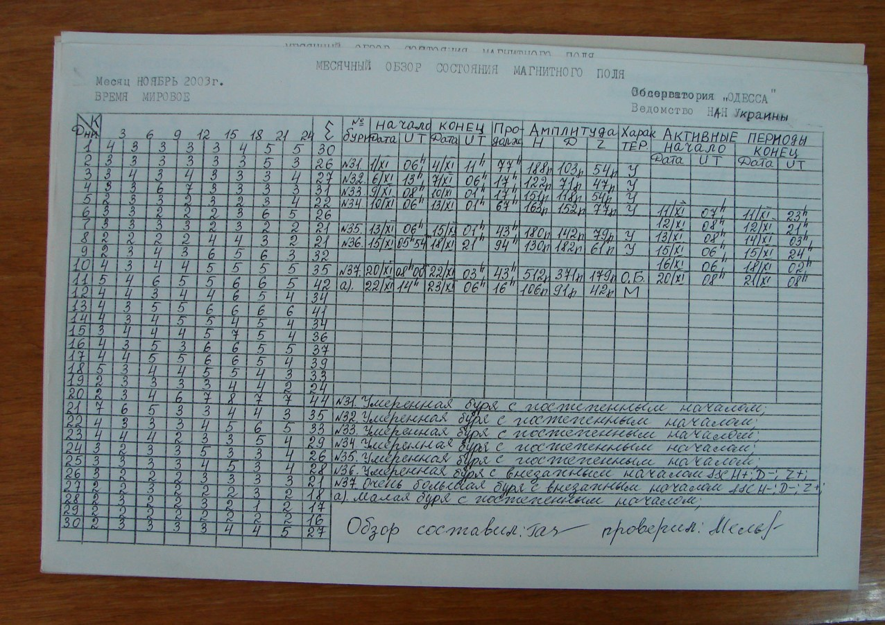

Fig. 5. Overview of the state of the magnetic field in November 2003

Electronic catalog of magnetic storms
On the basis of data of magnetic observatory «Odessa» the catalog the magnetic storms is made. This issue of the catalog for 1987-1995 and 2000-2009 years include: date and time of the beginning and end of a storm, the storm duration, amplitude on three elements of a magnetic field are specified: H, Z, D, the characteristic of magnetic storms with the indication of the fissile periods. The catalog was compiled to identify the reasons for the change in the level of the flux of space radio sources, according to observations at the URAN-4 radio telescope at the Odessa Observatory of the Radio Astronomy Institute of the National Academy of Sciences of Ukraine (fig. 6), which have been carried out since 1987. Data on changes in the fluxes of powerful radio sources during periods of extreme states of solar activity are presented in [3]. Paper [3] also presents the results of calculating multiple correlation analysis models, which demonstrates the dependence of changes in the radio sources fluxes on the main indicators characterizing the state of space weather.
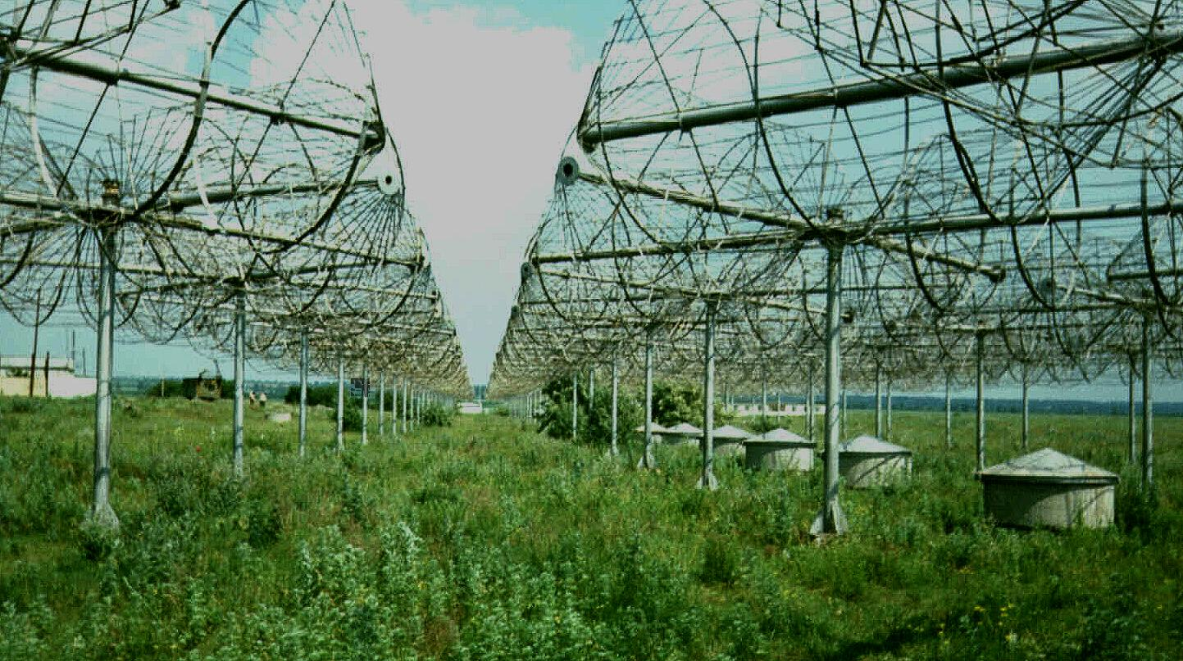
Let us consider the most extreme period of space weather of the 23rd solar activity cycle - November 2003. Changes in the radiation flux of the radio source 3C461 during this period are shown in Fig. 7. The stream changes of a radiation source are shown by small decrease of a stream on November 3-5 and the most noticeable decrease of a stream from November 17 to November 27. During the period from November 2 to November 4 in the Sun there were 4 flashes. The most potent flash (X>17.5) happened on November 4 that entailed recession in radiation source stream level. Recession of a stream of a radiation source was not too larger as the flash happened on the edge of a solar disk and its radiation poorly affected Earth. The next period of a superactivity began since November 17. It was followed by sharp recession of level of a flux of a radiation source which continued till November 27. For three days in this fissile area eight flashes of point of M from which two were larger were made. The flash of point 2N during which there were two flashes of x-ray point of M3.2 and M3.9 was on November 18 the most interesting event of this period. Potent emission of coronal substance of this flare event caused during very larger and intensive magnetic storm on November 20-21.
Fig. 6. The radio telescope URAN-4

Fig. 7. 3C461 radiation source flux variations on different hour corners (polarization – A, frequency – 25 MHz) in November, 2003
As an example, observational data of the magnetic observatory "Odessa" for the period January-March 2003 are presented at Table 1. The total number of minor, moderate, strong and extreme storms shown in table 2 and figure 8.
Table 1
Digital catalog of magnetic storms and their characteristics
Beginning |  | End |  | Duration, h | Amplitude |  |  | Storm class | Active periods |  |  |  | Comment
 |  |  |  |  |  |  |  |  | begin |  | end
date | UT | date | UT |  | Н | D | Z |  | date | UT | date | UT
03.01.2003 | 12:00 | 04.01.2003 | 0:00 | 36 | 95 | 94 | 36 | minor |  |  |  |  | Minor storm with the gradual beginning
18.01.2003 | 6:00 | 20.01.2003 | 6:00 | 48 | 105 | 64 | 39 | minor |  |  |  |  | Minor storm with the gradual beginning
20.01.2003 | 10:00 | 23.01.2003 | 4:00 | 66 | 98 | 68 | 38 | minor |  |  |  |  | Minor storm with the gradual beginning
29.01.2003 | 9:00 | 30.01.2003 | 20:00 | 35 | 116 | 124 | 42 | moderate |  |  |  |  | Moderate storm with the gradual beginning
01.02.2003 | 15:00 | 05.02.2003 | 3:00 | 84 | 176 | 145 | 82 | moderate | 01.02.2003 | 18:00 | 03.02.2003 | 2:00 | Moderate storm with the gradual beginning
 |  |  |  |  |  |  |  |  | 03.02.2003 | 12:00 | 04.02.2003 | 12:00
08.02.2003 | 7:00 | 09.02.2003 | 3:00 | 20 | 75 | 70 | 26 | minor |  |  |  |  | Minor storm with the gradual beginning
12.02.2003 | 8:00 | 13.02.2003 | 1:00 | 17 | 83 | 74 | 26 | minor |  |  |  |  | Minor storm with the gradual beginning
13.02.2003 | 21:00 | 15.02.2003 | 21:00 | 48 | 80 | 105 | 35 | minor | 14.02.2003 | 9:00 | 15.02.2003 | 18:00 | Minor storm with the gradual beginning
16.02.2003 | 6:00 | 17.02.2003 | 2:00 | 20 | 86 | 62 | 32 | minor |  |  |  |  | Minor storm with the gradual beginning
26.02.2003 | 6:00 | 28.02.2003 | 1:00 | 43 | 106 | 114 | 48 | moderate |  |  |  |  | Moderate storm with the gradual beginning
28.02.2003 | 6:00 | 01.03.2003 | 3:00 | 21 | 93 | 85 | 42 | minor |  |  |  |  | Minor storm with the gradual beginning
03.03.2003 | 15:00 | 05.03.2003 | 3:00 | 36 | 92 | 131 | 57 | moderate |  |  |  |  | Moderate storm with the gradual beginning
05.03.2003 | 9:00 | 07.03.2003 | 12:00 | 51 | 103 | 96 | 46 | minor |  |  |  |  | Minor storm with the gradual beginning
20.03.2003 | 6:00 | 22.03.2003 | 2:00 | 44 | 119 | 101 | 50 | moderate |  |  |  |  | Moderate storm with the gradual beginning
22.03.2003 | 19:00 | 24.03.2003 | 2:00 | 31 | 106 | 85 | 32 | minor |  |  |  |  | Minor storm with the gradual beginning
28.03.2003 | 16:00 | 31.03.2001 | 3:00 | 59 | 98 | 124 | 81 | moderate |  |  |  |  | Moderate storm with the gradual beginning
31.03.2003 | 6:00 | 01.04.2003 | 4:00 | 22 | 127 | 111 | 62 | moderate |  |  |  |  | Moderate storm with the gradual beginning

Table 2
Amount of magnetic storms in the catalog for 2000-2009
Storm class | 1987 | 1988 | 1989 | 1990 | 1991 | 1992 | 1993 | 1994 | 1995 | 2000 | 2001 | 2002 | 2003 | 2004 | 2005 | 2006 | 2007 | 2008 | 2009
minor | 21 | 41 | 28 | 24 | 19 | 31 | 27 | 19 | 23 | 25 | 31 | 39 | 38 | 31 | 30 | 32 | 34 | 28 | 11
moderate | 19 | 16 | 38 | 34 | 25 | 26 | 23 | 9 | 20 | 16 | 27 | 21 | 36 | 11 | 16 | 9 | 5 | 4 | 0
strong | 0 | 7 | 8 | 7 | 9 | 7 | 8 | 7 | 1 | 5 | 4 | 4 | 1 | 4 | 5 | 1 | 0 | 0 | 0
extreme | 0 | 1 | 4 | 1 | 9 | 1 | 0 | 1 | 0 | 3 | 6 | 2 | 2 | 2 | 4 | 0 | 0 | 0 | 0

Fig. 8. Graphical representation of the number of magnetic storms in the catalog.

Magnetic anomaly zone
The magnetic observatory "Odessa" is situated near the intensive magnetic anomaly. Since the dome of the geomagnetic field extends to an altitude of about 90 km, into the ionosphere layer, where the variation (rapidly variable) component of the geomagnetic field is formed, regional magnetic anomalies can affect the manifestation of the variability of the geomagnetic field. When processing long-term, long-term observational data, the influence of the magnetic anomaly on the geomagnetic activity of the Earth was revealed. The map of the distribution of the anomalous geomagnetic field over the territory of Ukraine is shown in Figure 9.

.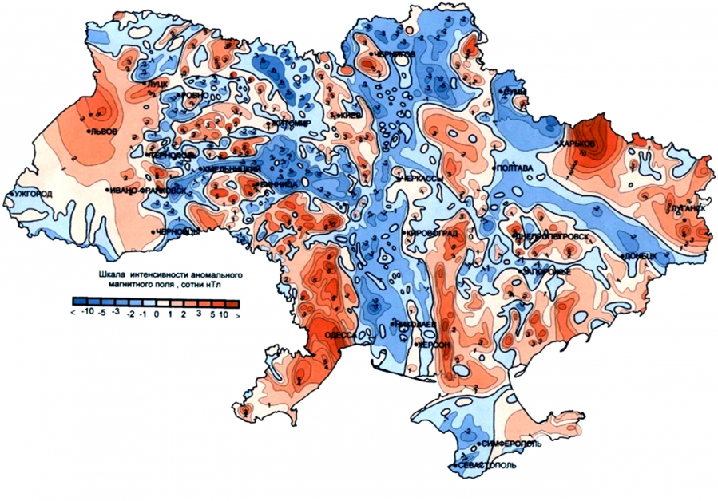
Fig. 9. Map of the anomalous geomagnetic field of Ukraine, obtained as a result of research carried out at the Institute of Geophysics of the National Academy of Sciences of Ukraine.

The identification of the magnetic anomaly influence on geomagnetic activity comparison of characteristics of magnetic storms at according to the magnetic observatories "Odessa" and “Moscow” was carried out. The total duration of all magnetic storms throughout the year in Odessa is more than in Moscow (IZMIRAN) (fig. 10). Table 3 provides information on the duration of individual magnetic storms in the magnetic observatories "Odessa" and IZMIRAN for 1987-1995 and 2001-2003.

Fig. 10. The total annual duration of magnetic storms according to the magnetic observatories "Odessa" and “Moscow”

Table 3
The duration of the most intense magnetic storms according to the data of the magnetic observatories "Odessa" and "Moscow" (IZMIRAN) for 2001-2003
2001 |  |  | 2002 |  |  | 2003
Date | Odessa | Moscow | Date | Odessa | Moscow | Date | Odessa | Moscow
19.03.2001 | 38 | 40 | 10.01.2002 | 89 | 30 | 24.04.2003 | 108 | 41
28.03.2001 | 35 | 28 | 17.04.2002 | 43 | 21 | 26.06.2003 | 102 | 41
31.03.2001 | 70 | 9 | 19.04.2002 | 39 | 9 | 15.07.2003 | 52 | 2
08.04.2001 | 35 | 24 | 11.05.2002 | 30 | 22 | 28.07.2003 | 157 | 40
11.04.2001 | 29 | 18 | 23.05.2002 | 12 | 9 | 20.08.2003 | 116 | 56
18.04.2001 | 34 | 10 | 01.08.2002 | 88 | 26 | 15.09.2003 | 127 | 56
17.08.2001 | 36 | 8 | 01.10.2002 | 45 | 61 | 16.10.2003 | 91 | 40
21.10.2001 | 48 | 4 | 03.10.2002 | 65 | 50 | 15.11.2003 | 94 | 2
05.11.2001 | 62 | 40 | 02.11.2002 | 125 | 20 | 20.11.2003 | 43 | 9

Сonclusions
1. On the base of data of magnetic observatory «Odessa» the catalog the magnetic storms is made. This issue of the catalog for 1987- 1995 and 2000-2009 years include: date and time of the beginning and end of a storm, the storm duration, amplitude on three elements of a magnetic field are specified: H, Z, D, the characteristic of magnetic storms.
2. The comparison duration of magnetic storms according to the magnetic observatory "Odessa" is longer than at “Moscow” (IZMIRAN).
3. It is planned to create a catalog of magnetic storms according to the Odessa station for the entire monitoring period of space radio sources at the RT URAN-4 in order to identify manifestations of geomagnetic disturbances during radio astronomical observations and their contribution to changes in radio source fluxes on decameter waves.
4. These studies will be supplemented by a comparative analysis of the characteristics of magnetic storms in the magnetic anomaly zone (Odessa) with data from other magnetic observatories.
5. The complete content of the magnetic storms catalog will be presented on the pages of the Institute of Geophysics NAS of Ukraine (http://www.igph.kiev.ua/rus/structure/6.html) and the Radio-astronomical Institute of NAS of Ukraine (http://rian.kharkov.ua /index.php/ru/)

References
1. Orliuk Mykhailo, Sumaruk Yuri, Sumaruk Taras, Romenets Andriy, Melnychuk Igor. Geomagnetic observatories of the Ukraine: equipment, measurement practice and data interpretation. The IAGA11th Scientific Assembly in Sopron, Hungary. – 2009, http://www.iaga2009sopron.hu/abstracts/
2. L.I. Sobitnyak, M.I. Ryabov, A.L. Sukharev, M.I. Orlyuk, A.O. Romenets, Yu.P Sumaruk. The catalog of magnetic storms for Odessa magnetic anomaly zone. Odessa Astronomical Publications, 2018, Vol. 31, P. 163-166
3. L.I. Sobitniak, M.I. Ryabov, A.L. Sukharev, S.K. Panishko. Structure of variability indexes of cosmic weather as applied to data monitoring of fluxes of radio sources at the “URAN-4” radio telescope. RADIO PHYSICS AND RADIO ASTRONOMY, 2017, Vol. 22, No. 4, P. 294
4. M.I. Ryabov, A.L. Sukharev, M.I. Orlyuk, L.I. Sobitnyak, A.A. Romenets. Comparative analysis of geomagnetic disturbances in the Odessa magnetic anomaly area in the 24th solar activity cycle. RADIO PHYSICS AND RADIO ASTRONOMY, 2019, Vol. 24, No. 1, P. 68
5. A.L. Sukharev, M.I. Orlyuk, M.I. Ryabov, A.A. Romenets. On the First Results of Measurements of Geomagnetic Short-Period Field Variations in the Odesa Magnetic Anomaly Zone with a Second-Long Resolution. RADIO PHYSICS AND RADIO ASTRONOMY, 2018, Vol. 23, No. 2, P. 116

